Title : Perform the data classification using classification algorithm. Or perform the data
clustering using a clustering algorithm.
Name : - Mehatab Mahibub Sanadi
Roll No. : - CO4050
Class : - BE Computer
Subject : - Business Intelligence
*********************************************************************
Step 1: Open Tableau
Launch Tableau
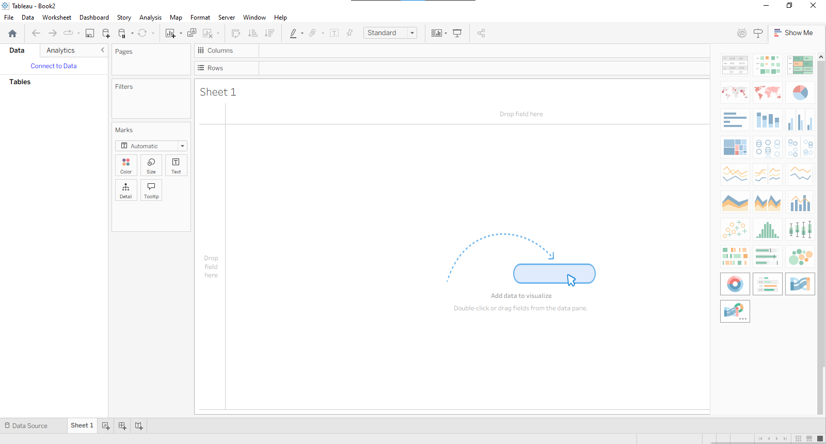
Step 2: Load Iris Dataset
Click Connect → Text File / Excel
Select your Iris dataset file (CSV/Excel)
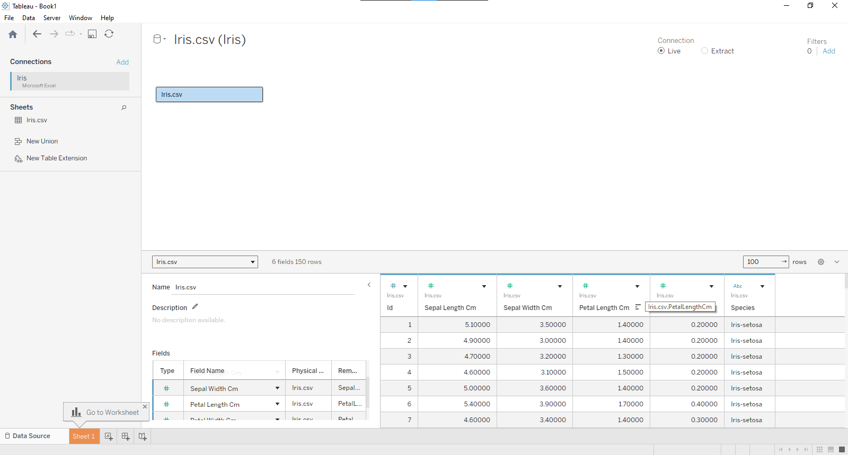
Step 3: Create Scatter Plot
Drag:
Petal Length → Columns
Petal Width → Rows
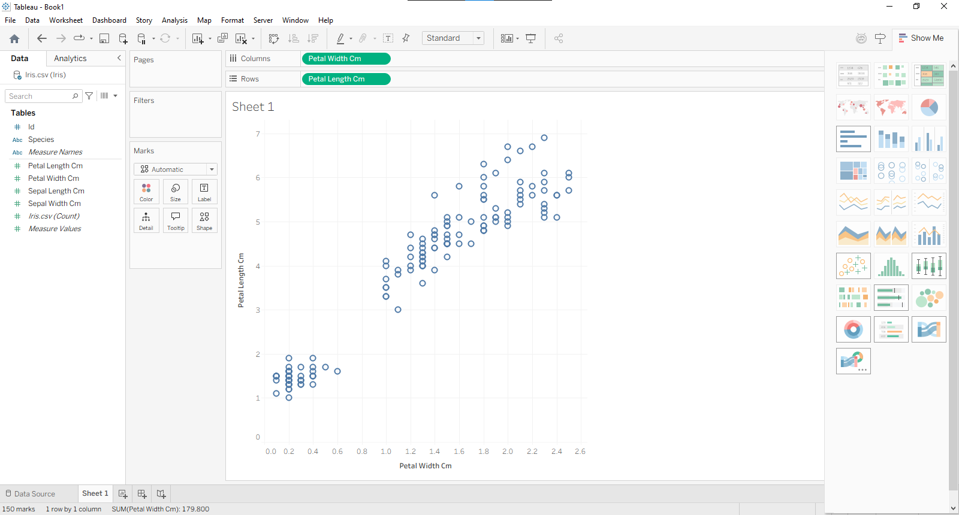
Step 4: Add Data Points Detail
Drag Species → Color (optional, for comparison)
OR drag it to Detail
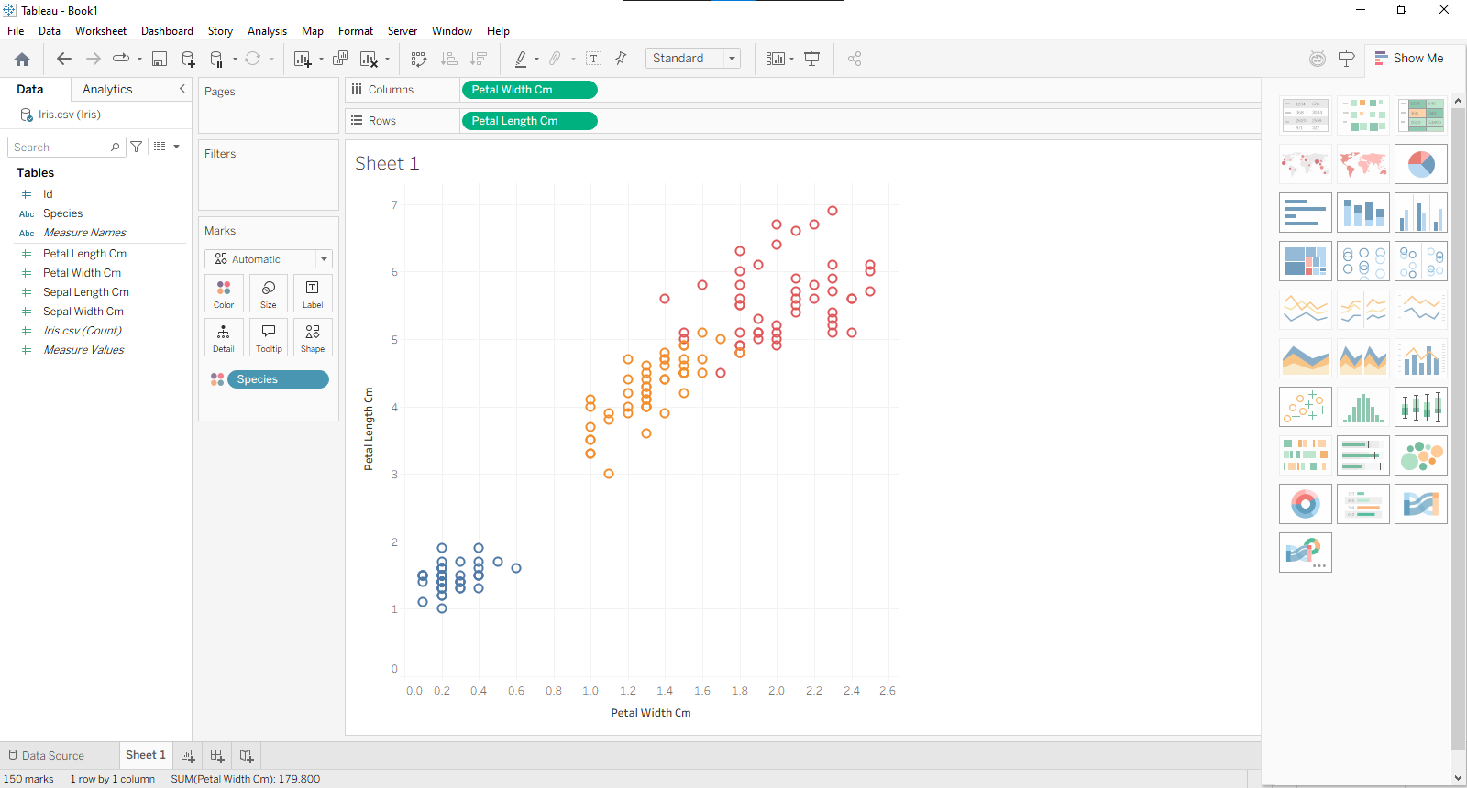
This helps you verify clustering accuracy later
Step 5: Open Analytics Pane
Click Analytics tab (top-left)
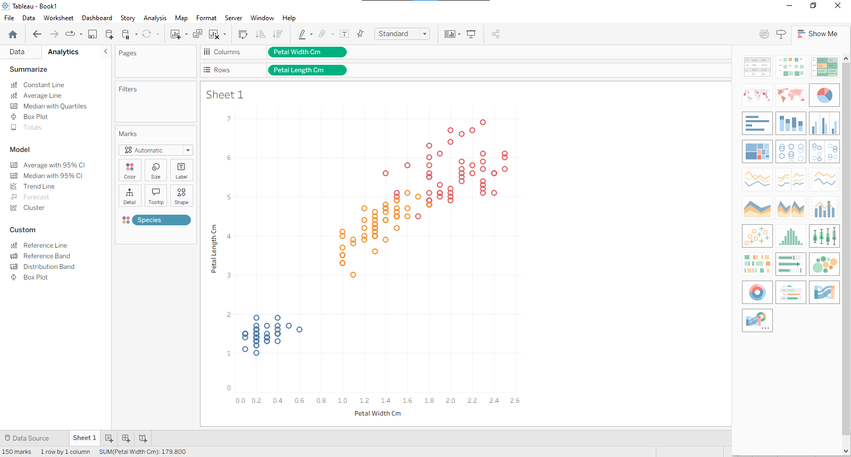
Step 6: Apply Clustering
Drag “Cluster” → Drop on chart

Step 7: Set Number of Clusters
On left panel:
Click Clusters
Set:
Number of clusters = 3
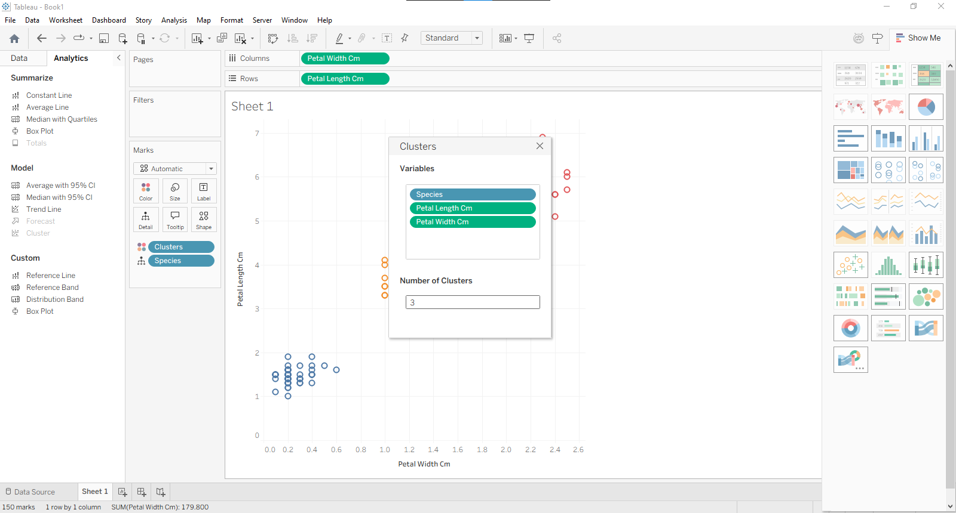
Step 8: Customize Clusters
Tableau will color clusters differently
Rename clusters if needed:
Cluster 1, Cluster 2, Cluster 3
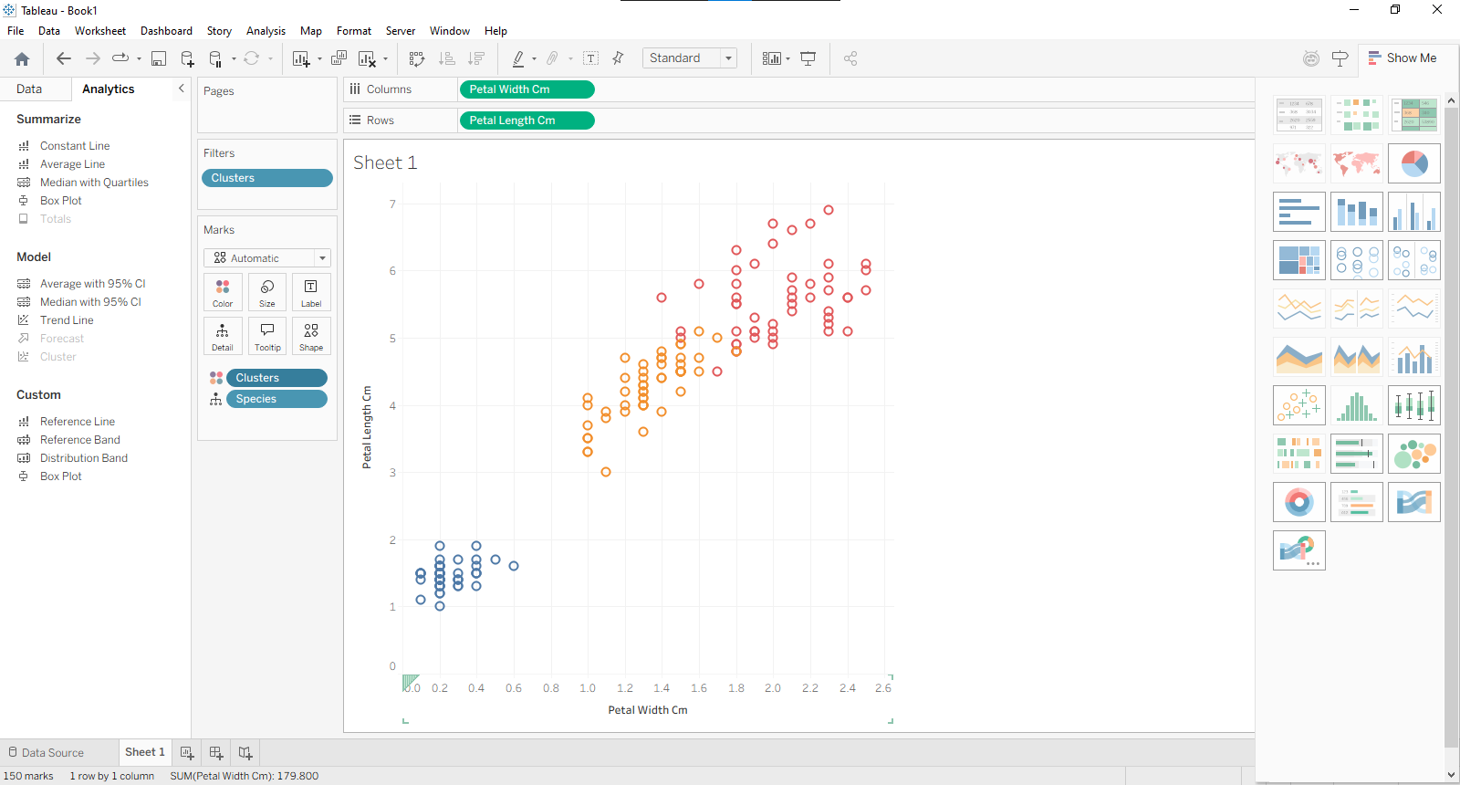
Step 9: Analyze Clusters
Observe:
- One cluster will be clearly separated (Setosa 🌸)
- Two clusters slightly overlap (Versicolor & Virginica)

Conclusion: In this way we implement classification and clustering using Tableau.

